Western Australian Certificate of Education
Semester One Examination 2016
Question/Answer Booklet

PHYSICS
SOLUTIONS

Name:_______________________________________
Teacher:_______________________________________

Time allowed for this paper
Reading time before commencing work: Ten minutes
Working time for paper: Three hours
Material required/recommended for this paper
To be provided by the supervisor
This Question/Answer Booklet
Physics: Formulae, Constants and Data Sheet
To be provided by the candidate
Standard Items: Pens, pencil, eraser, correction fluid, ruler, highlighter
Special Items: non-programmable calculators satisfying the conditions set by the Curriculum Council for this course, drawing templates, drawing compass and a protractor

Important note to candidates
No other items may be taken into the examination room. It is your responsibility to ensure that you do not have any unauthorised notes or other items of a non-personal nature in the examination room. If you have any unauthorised material with you, hand it to the supervisor before reading any further.
Structure of this paper
Section | Number of questions available | Number of questions to be answered | Suggested working time  (minutes) | Marks available | Percentage of exam
Section One:  Short response | 14 | 14 | 50 | 54 | 30
Section Two:  Problem-solving | 6 | 6 | 90 | 90 | 50
Section Three:  Comprehension | 2 | 2 | 40 | 36 | 20
 |  |  |  | Total | 100

Instructions to candidates

1. The rules for the conduct of Western Australian external examinations are detailed in the Year 12 Information Handbook 2016. Sitting this examination implies that you agree to abide by these rules.

2. Write answers in this Question/Answer Booklet.

When estimating numerical answers, show your working or reasoning clearly. Give final answers to a maximum of two significant figures and include appropriate units where applicable.
4. You must be careful to confine your responses to the specific questions asked and to follow any instructions that are specific to a particular question.

5. Spare pages are included at the end of this booklet. They can be used for planning your responses and/or as additional space if required to continue an answer.
- Planning: If you use the spare pages for planning, indicate this clearly at the top of the page.
- Continuing an answer: If you need to use the space to continue an answer, indicate in the original answer space where the answer is continued, i.e. give the page number.
Fill in the number of the question(s) that you are continuing to answer at the top of the page.
SECTION ONE: Short Response 30% (54 marks)
This section has 14 questions. Answer all questions.
When calculating numerical answers, show your working or reasoning clearly. Give final answers to three significant figures and include appropriate units where applicable.
When estimating numerical answers, show your working or reasoning clearly. Give final answers to a maximum of two significant figures and include appropriate units where applicable.
Spare pages are included at the end of this booklet. They can be used for planning your responses and/or as additional space if required to continue an answer.
- Planning: If you use the spare pages for planning, indicate this clearly at the top of the page.
- Continuing an answer: If you need to use the space to continue an answer, indicate in the original answer space where the answer is continued, i.e. give the page number. Fill in the number of the question that you are continuing to answer at the top of the page.
Suggested working time: 50 minutes.

Question 1 (4 marks)
A charged particle of charge +155 nC has a mass of 2.10 g and is in an electric field as shown below. The particle is suspended because the force of gravity down is equal and opposite to the electric force which is up. Find the magnitude of the electric field strength between the plates.
- - - - - - - - - - - - - - - - - - - - - - - - - - -
+ + + + + + + + + + + + + + + + + + + + + + + + + + +

F_{E} = F_{g}
Eq = mg ✓
E = mg/q ✓
= (0.0021)(9.8)/1.5x10⁻⁶ ✓
= 1.37x10⁴ N/C (V/m) ✓

Question 2 (3 marks)
Two cannons fire identical cannonballs at identical speeds and at identical angles of 45º to the horizontal. Cannon A is at ground level and cannon B is 25 m above ground level. Which cannon will fire its cannonball with the greatest horizontal range? Justify your answer. You may ignore the effects of air resistance.
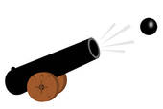

Cannon B
Cannon A
25 m

Cannon B ✓
Cannon B will have a greater “time of flight” as it has a greater vertical displacement ✓
Both cannons have same horizontal velocity, but cannon B will have greater horizontal displacement as S_{H}=V_{H} x t ✓

Question 3 (2 marks)
A shot-putter throws a shot at an angle to the horizontal. Air resistance is negligible.
C ✓
Which of the following graphs best represents the horizontal component of the
shot’s velocity from the time it is launched to the time just before it hits the ground?

Which of the following graphs best represents the vertical component of the shot’s
B ✓
velocity from the time it is launched to the time just before it hits the ground?

Question 4 (4 marks)
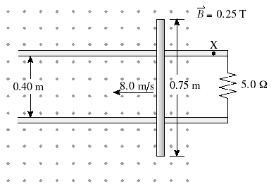
A 0.75 m metal rod is moving to the left at 8.0 m s⁻¹ as shown in the diagram. It is in contact with two conducting rails that make a circuit with a 5.0 Ω resistor. There is a 0.25 T magnetic field directed out of the page. Find the magnitude of the induced current passing through the resistor and show the direction of the induced current at position “X”.

emf = Bvl
= 0.25 x 8.00 x 0.40 ✓
= 0.80 V ✓
I = emf/R ✓
= 0.8/5.0
= 0.16 A ✓

Question 5 (4 marks)
A 25.0 kg sign is suspended by two cables as shown in the diagram. The cables make an angle of 105º with each other and have the same length. Find the tension in each cable.
105º
Open for Business

Each cable will have the same tension “T” (symmetry) ✓
ΣF_{y} = 0
2Tsin37.5 ✓ = 25 x 9.8 ✓
T =201 N ✓

Question 6 (2 marks)
A simple AC generator was connected to a cathode ray oscilloscope and the coil was rotated at a constant rate. The output is shown on this graph below.
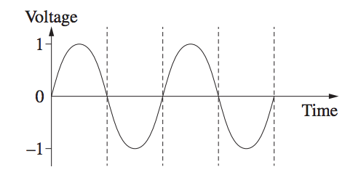

On the axes below, sketch how the output would look if the speed of rotation was halved.
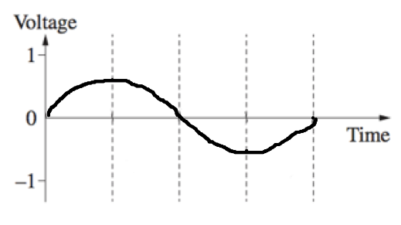
Period doubled ✓
Amplitude halved ✓

Question 7 (4 marks)
The diagram below shows an ideal transformer. When the switch is closed, the galvanometer deflects and then returns to a zero reading.
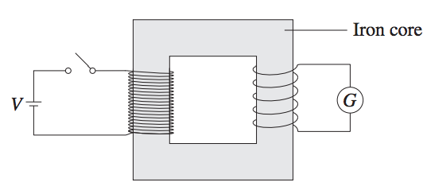

Explain why the galvanometer only shows a reading for a brief moment and then returns to zero.
As the switch is closed, current increases in the primary coil, which produces a magnetic field. So the secondary coil experiences a momentary change in flux ✓
Therefore a momentary emf is induced in the secondary coil ✓

2Tsin37.5 ✓ = 25 x 9.8 ✓
T =201 N ✓

State two ways of increasing the magnitude of deflection on the galvanometer.
1. increase the turns ration N_{s}/N_{p} ✓
2. Increase V ✓

Question 8 (3 marks)
The diagram below shows an aerial view of a train that is travelling west. Hamish rolls a ball directly between points A and B. However, the ball takes the path as shown. What can be inferred about the motion of the train? Explain your answer.
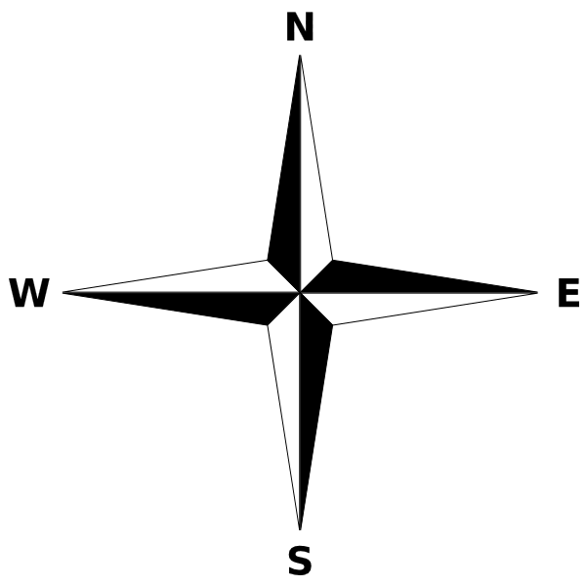
B
A
FRONT OF TRAIN

The train is decelerating (i.e. accelerating East)✓
The ball has inertia in the Westerly direction and the train is decelerating under it, i.e relative to the train, the ball is accelerating to the West ✓
Therefore the ball takes a parabolic path as shown ✓
(or words to that effect)

Question 9 (4 marks)
A 20 kg bicycle is suspended via a rope that passes through pullies as shown in the diagram. There is a dc motor that drives a 5.00 cm radius pulley to raise and lower the bike. What minimum torque is required by the motor to raise the bicycle? Assume that all three ropes that attach to the bicycle have the same tension.
3T = 196 N ✓
T = 65.3 N ✓
Torque = 65.3 x 0.05 ✓
= 3.27 Nm ✓

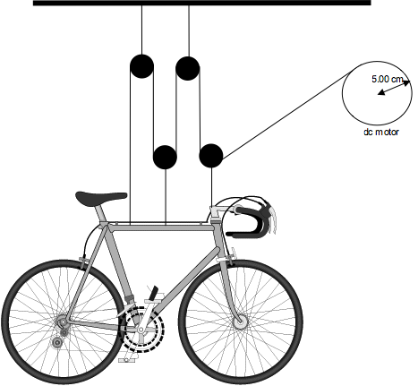
Question 10 (5 marks)
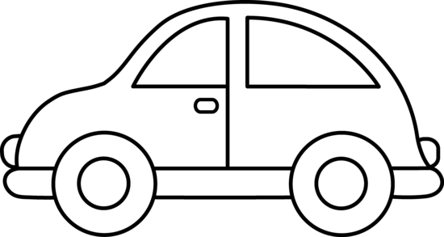
A toy car of mass 125.0 g is on a track that forms part of a vertical circle of radius of 1.5 m. At the lowest point, B the car has a speed of 4.20 m s⁻¹. Draw the resultant force on the car at point B, as an arrow labelled “F_{net}” and find the force exerted by the track on the car at this point.
F_{net} = R - mg ✓
R = mv²/r + mg ✓
= (0.125)(4.20)²/1.5 + (0.125)(9.8) ✓
= 2.70 N ✓

1.50 m

F_{net} ✓

Question 11 (4 marks)
Kepler’s third law is defined as: “The square of the orbital period of a planet is directly proportional to the cube of the radius of its orbit”, or as is on the data sheet:
Beginning with Newton’s Universal Law of gravitation and the formula for centripetal force (both on the data sheet); derive Kepler’s third law. Full working must be shown.
F_{c} = F_{g}
mv²/r = GMm/r² ✓
(2πr/T)² = GM/r ✓
4π²r²/T² = GM/r ✓
T²/r² = 4π²/GM ✓

Question 12 (6 marks)
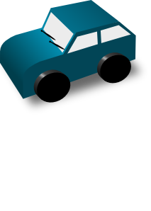
A motorised model car of mass 1.8 kg is travelling around a banked track of radius 1.5 m. The track is banked so that there is no sideways friction between the car and the track. The car travels a constant speed of 2.0 m s⁻¹.
1.5 m

On the diagram below, show as labelled solid arrows, all forces acting on the car. Show the net force as a labelled dashed arrow.
Normal reaction force ✓

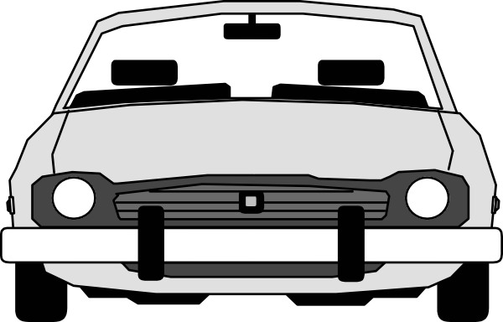
F_{net} ✓

Weight ✓

Find the required banking angle for there to be no sideways friction required.
Θ = tan⁻¹(v²/rg) ✓
= tan⁻¹(2.0²/(1.5)(9.8)) ✓
= 15.2 º ✓

Question 13 (4 marks)
The diagram below shows a conductor carrying a 234 mA current in the direction shown. Point P is 23.5 cm from the conductor and on the same plane. State the direction of the magnetic field at P and find the magnetic field strength at this point.
Direction of field is into page ✓
B = (μ₀/2π)(I/r) ✓
= (2 x 10⁻⁷)(0.234/0.235) ✓
= 1.99 x 10⁻⁷ T ✓
P

Question 14 (5 marks)
A beam of electrons is moving at a speed of 3.44 x 10⁷ ms⁻¹ and enters a region of perpendicular magnetic field of strength 0.150 T, as shown in the diagram below.

X X X X X

X X X X X
Electron beam
X X X X X
✓
✓

✓

X X X X X

X X X X X

X X X X X

- What is the direction of the magnetic force on the electrons in the beam as they enter the region of magnetic field? Circle the correct answer:
✓
LEFT RIGHT DOWN UP INTO PAGE OUT OF PAGE
(b) Calculate the size of the magnetic force acting on each electron in the beam as it enters the region of magnetic field.
F = Bvq ✓
= (0.150)(3.44 x 10⁷)(1.6 x 10⁻¹⁹) ✓✓
= 8.26 x 10⁻¹³ N ✓

(c) On the diagram above, sketch the approximate path that the electron beam will take as it moves through the region of magnetic field.

End of Section One
This page has been left blank intentionally
SECTION TWO: Problem-solving 50% (90 marks)
This section has six (6) questions. Answer all questions. Write your answers in the spaces
provided.
Spare pages are included at the end of this booklet. They can be used for planning your
responses and/or as additional space if required to continue an answer.
- Planning: If you use the spare pages for planning, indicate this clearly at the top of the page.
- Continuing an answer: If you need to use the space to continue an answer, indicate in the original answer space where the answer is continued, i.e. give the page number. Fill in the number of the question that you are continuing to answer at the top of the page.
Suggested working time: 90 minutes.

Question 16 (13 marks)
Amy kicks a soccer ball at 10.0 m s⁻¹. The ball reaches a maximum height of 4.00 m during its flight. For Parts (b) to (f) you may ignore the effects of air friction.
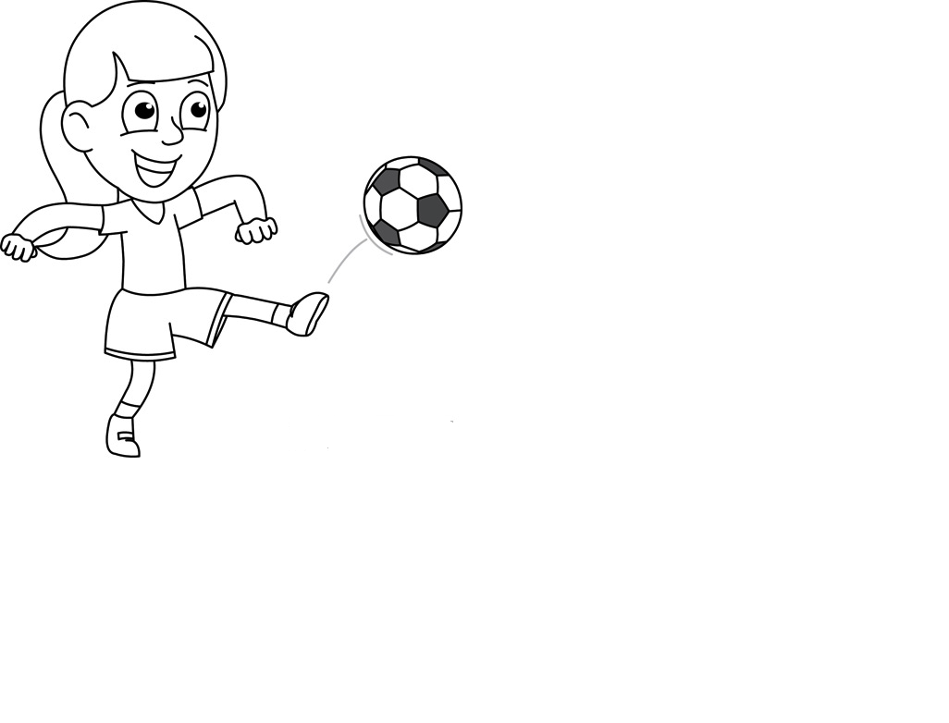

Air resistance ✓
Weight ✓

(a) In the diagram above, the ball has just been kicked. Show clearly as labelled arrows, all forces acting on the ball at this instant. (2 marks)
(b) At what angle to the horizontal was the ball kicked? (4 marks)
At max height v_{v}=0
0² = u_{v}² + 2(-9.8)(4.00) ✓
u_{v} = 8.85 m/s ✓
10.0 sinθ = 8.85 m/s ✓
θ = 62.3º ✓

(c) What is the ball’s speed at its maximum height? (2 marks)
u_{h} = ucosθ
= 10.0 cosθ ✓
= 4.65 m/s ✓

(d) What is the ball’s acceleration at it’s maximum height? (1 mark)
9.80 m/s² downwards ✓
(e) Find the horizontal range of the kick. (2 marks)
R = u²sin2θ/g
= (10.0)²sin(2 x 62.3) ✓
= 8.40 m ✓

(f) Find the range of the kick if the ball was kicked from a point 1.56 m above the ground. (3 marks)
For vertical:
v_{v}² = u_{v}²+(2)(a)(s)
= (8.85)² + 2(-9.80)(-1.56)
v_{v} = -10.4 m/s ✓
t = (v_{v}-u_{v})/a
= (-10.4-8.85)/-9.8
= 1.97 s ✓
For horizontal:
s_{h} = u_{h} x t
= (4.65)(1.97)
= 9.15 m ✓

Question 17 (13 marks)
An alpha particle consists of two protons and two neutrons and has a mass of 6.64 x 10⁻²⁷ kg and a charge of 3.2 x 10⁻¹⁹ C.
(a) Find the force of repulsion between two alpha parties that are 0.150 nm apart. (2 marks)
$$F= \frac{1}{4πε_{0}}\frac{q_{1}q_{2}}{r^{2}}$$ = 9 x 10⁹ x (3.2 x 10⁻¹⁹)²/(1.5 x 10⁻¹⁰)² ✓
= 4.1 x 10⁻⁸ N ✓

In a particle accelerator, an alpha particle is accelerated from rest through a potential difference of 2.40 kV.
(b) Find the work done on the particle by the electric field and hence the final speed of the particle. (3 marks)
W = qV
= (3.2 x 10⁻¹⁹)(2.40 x 10³)
= 7.68 x 10⁻¹⁶ J ✓
KE = ½ mv²
7.68 x 10⁻¹⁶ = ½ (6.64 x 10⁻²⁷)v² ✓
v = 4.81 x 10⁵ m/s ✓

The alpha particle then enters a region between two parallel plates that are 60.0 mm apart. There is a potential difference of 550 V between the plates. The metal plates are 2.50 cm long.
The particle enters the region between the plates midway between the plates.
60.0 mm
550 V
0 V
2.50 cm
path of alpha particle

(c) Define the term “electric field strength”. (1 mark)
Electric field strength is the force per unit charge experienced at any point in space ✓

(d) Find the electric field strength between the two plates. (2 marks)
E = V/d
= 550/0.06 ✓
= 9 170 V/m (N/C) ✓

(e) Find the magnitude and direction of the acceleration of the alpha particle as it passes between the plates. (2 marks)
a = F/m
= qE/m ✓
= (3.2 x 10⁻¹⁹)(9170)/6.64 x 10⁻²⁷
= 4.42 x 10¹¹ m/s² down ✓

(f) Does the alpha particle pass through the plates or does it hit one of the plates? Justify your answer with suitable calculations. (3 marks)
t to pass through plates:
t = d/v
= 0.025/4.81 x 10⁵
= 5.20 x 10⁻⁸ s ✓
s_{v} = ut + ½ at²
= (½)(4.42 x 10¹¹)(5.20 x 10⁻⁸)²
= 5.97 x 10⁻⁴ m < 0.6 mm ✓ therefore will pass through ✓


Question 18 (15 marks)
Eloise is playing “Totem Tennis”. At any particular instant, the string attached to the ball makes an angle of θº to the vertical and the ball is moving at a constant speed, v in a horizontal circle of radius r.
The diagram below shows the tennis ball on the end of the string.
(a) Show as clearly labelled arrows, all forces acting on the ball. (2 marks)
r
θº

Tension ✓

F_{net} ✓
Weight ✓

(b) Show the net force acting on the ball as a clearly labelled arrow. (1 mark)
(c) Show that for the situation above, $tanθ=\frac{v^{2}}{rg}$ (3 marks)
Note: F_{net} = mv²/r
tanθ = mv²/r/mg ✓
= v²/rg ✓
✓

θº
mg

mv²/r

Eloise decided to conduct an experiment that could use the above relationship and several sets of results to determine “g”. She used her phone to record video of the motion of the ball for several different speeds. She then analysed the video and prepared a table to record and analyse her data. The heading row for her table is shown below.

Θ (º) | T (s) | r (m) | V = 2πr/T (m/s) ✓ | V²  (m²/s²) ✓ | V²/r  (m/s²) ✓ | Tan θ ✓

(d) Fill in the heading row for the other columns, to show how the data would need to be manipulated to produce a straight line graph. Note: T is the time for one revolution. (4 marks)

(e) Clearly explain how this manipulated data could be graphed and analysed to determine “g”. Be sure to mention the significance of the gradient of the plotted graph. (3 marks)
- Graph tanθ on the vertical axis and v²/r on the horizontal axis ✓
- Determine the gradient ✓
- Gradient value = 1/g, so g = 1/gradient ✓

(f) State one source of uncertainty in Eloise’s experiment and describe how she could reduce the uncertainty of this source. (2 marks)
Any acceptable, eg: measuring θ from the video, measuring r from the video, determining period from the video ✓
Any acceptable, eg: using a higher frame-rate camera, placing a ruler in the frame to use as a scale ✓
- Gradient value = 1/g, so g = 1/gradient ✓

Question 19 (14 marks)
A 25.0 kg uniform beam PQ is supporting a 60 kg load as shown in the diagram. A cable AB is attached 2.0 m from a frictionless hinge at P, at right angles.
60 KG
A
12 m
B
P
Q
10 m
65º
T

(a) Find the tension in the cable AB for the position shown. (3 marks)
Take torques about P:
Στ_{cw} = Στ_{acw}
T(2.0) = (245)(6)(sin65º) + (588)(12)(sin56º)✓✓
T = 3,860 N ✓
✓
✓

(b) Find the (reaction) force exerted on the beam by the hinge at P. Be sure to find the magnitude and direction of this force. (5 marks)
Note: T is at 25º to the vertical (90-65)
ΣF_{h} = 0 ΣF_{v} = 0
R_{h} = 3860 x sin25º R_{v} = 588 + 245 – (3,860 x cos25º)
= 1631 N ✓ = -2,670 N (i.e. down) ✓

R² = 1631² + (-2,670)²
R = 3,130 N ✓
Θ = tan-1(2,670/1,631)
= 58.5º✓
i.e. Reaction force is 3,130 N, 58.5º below horizontal and to the right.

(c) The beam is then lowered by lengthening cable AB. Explain the effect that this change will have (if any) on the following. Clearly explain your reasoning. (6 marks)

 | Change (increase, decrease unchanged) | Explanation
Magnitude of tension in AB | Increase ✓ | CW torque increases as both weights are further from pivot. T increases to provide opposing ACW torque. ✓
Horizontal component of reaction force on beam at P. | Increase ✓ | As T increases, so does its horizontal component. So R_{h} must increase to maintain horizontal equilibrium. ✓
Vertical component of reaction force on beam at P. | Increase ✓ | As T increases, so does vertical component of T (which is up). So R_{v} (which is down) must increase to maintain vertical equilibrium. ✓

Question 20 (17 marks)
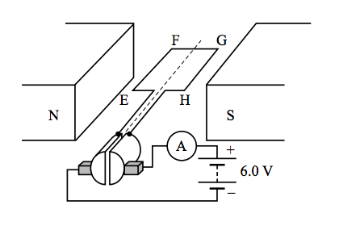
Two Year 12 students were given a model DC motor to experiment with in class. The two magnets provide a uniform magnetic field of 1.50 mT. EFGH is a square coil of side length 5.00 cm with 20 turns. A 6.00 V battery and an ammeter are connected as shown.

(a) When the motor is first switched on, the ammeter shows a current of 5.13 A. Find the magnitude and direction of the force on side GH. (2 marks)
F = ILBn
=(5.13)(0.05)(0.0015)(20)✓
= 7.70 x 10⁻³ N✓

(b) Once the motor had started spinning, the current dropped to 0.15 A. Explain why the current dropped by making reference to Lenz’s Law. (2 marks)
The spinning armature induces an emf which opposes the external voltage (Lenz’s Law)✓This reduces the net emf and thus the current drawn by the motor. ✓ i.e back emf

(c) Is the position shown, a position of maximum or minimum torque? Explain. (2 marks)
Position of maximum torque ✓
EF and GH are at maximum perpendicular distance from the axis of rotation ✓

(d) Find the maximum torque produced by this motor when the current is 0.15 A. (3 marks)
Τorque_{max} = BINA
= (0.0015)(0.15)(20)(0.05)²✓ ✓
= 1.13 x 10⁻⁵ Nm✓
(or recalculate F for I=0.15 A and multiply by r and multiply by 2 (2 sides))

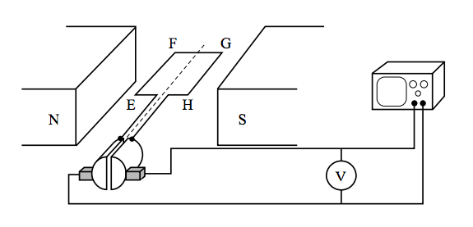
The students then reconfigure the motor so it operates as a dc generator as shown below. They do this by replacing the battery with a voltmeter and cathode ray oscilloscope to analyse the emf produced.

(e) On the axes below, sketch how the induced emf varies with time as the coil is rotated at a constant rate. No scales on the axes are required. At t=0, the coil is in the position shown above. Sketch the emf for two complete revolutions. (2 marks)
V
t
0
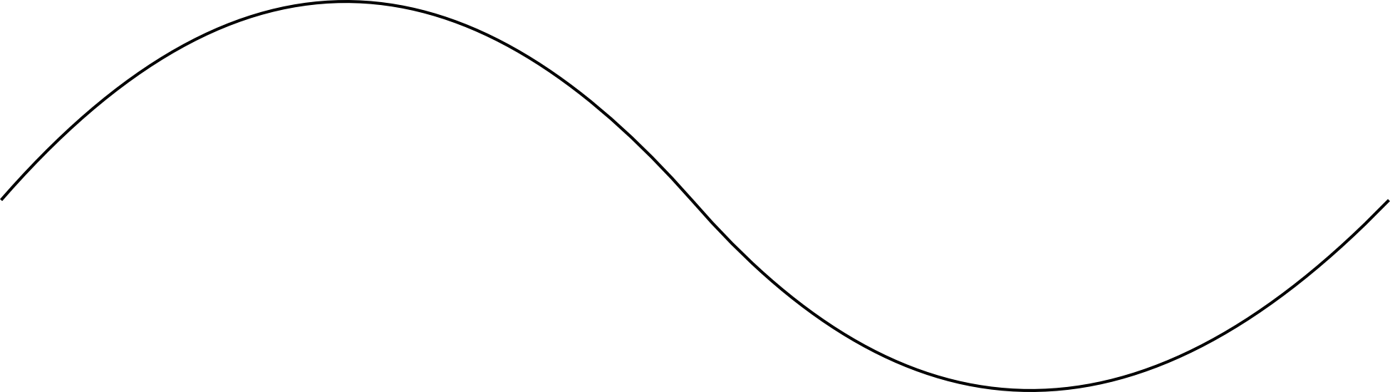




✓✓

(f) The students then converted the dc generator into an ac generator, what changes did they need to make? (2 marks)
The students would have replaced the split ring commutator with slip rings ✓ ✓

The students then rotated the ac generator at a steady rate of 60 revolutions per minute.
(g) What maximum emf was produced? (2 marks)
ε_{max} = 2πBANF
= 2π(0.0015)(0.05)²(20)(1)✓
= 4.71 x 10⁻⁴ v✓

(h) What average (RMS) emf was produced? (2 marks)
ε_{rms} = ε_{max}/√2
= 4.71 x 10⁻⁴ / √2 ✓
= 3.33 x 10⁻⁴ v ✓

Question 21 (18 marks)
Western Power is trialling an experimental hydroelectric power scheme at Leonora. The town’s main water supply is pumped from Perth and then stored at a considerable height above the town itself in a large dam. Water flowing from the dam to the town is used to turn turbines in the hydroelectric plant. These turbines are connected to ac generators that produce electricity that is “stepped up” to 50 000 V_{RMS} before it is transmitted to Leonora via 20 km of transmission lines. At the edge of town, there is a “step down” transformer that converts the voltage to 250 V_{RMS} for use in Leonora. The current in the transmission lines is 23.0 A _{RMS} The system is represented below.
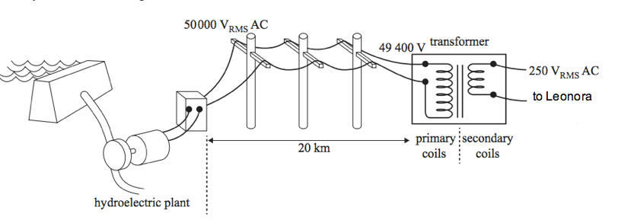
(a) Find the power provided to the transmission lines. (2 marks)
P = VI
= (50000)(23.0) ✓
= 1.15 x 10⁶ W✓

(b) Find the resistance of the transmission lines. (2 marks)
V_{drop} = IR
R = 600/23.0 ✓
= 26.0 Ω ✓

(c) What is the percentage of power lost due to the resistance of the power lines? (2 marks)
%_{loss} = 600/50000 (100) ✓
R = 1.2% ✓

(d) Find the turns ratio (primary to secondary) of the transformer at the edge of town. (2 marks)
N_{p}/N_{s} = V_{p}/V_{s}
= 49400/250 ✓
= 198 ✓

(e) Explain clearly, why it is essential for Western Power to “step up” the voltage before transmitting electricity to Leonora. (2 marks)
Stepping up the voltage means lower current ✓ so power losses due to the resistance of the lines is reduced (I²R) ✓

(f) Explain why power utilities such as Western Power transmit ac electricity over large distances and not dc. (2 marks)
ac can be easily stepped up and down via transformers ✓ dc can not be stepped up or down ✓

(g) In industry, complex devices are used to convert ac to dc. This is called voltage rectification. Explain how a motor and a generator could be used to rectify alternating current. (2 marks)
An ac motor could be mechanically connected to a dc generator ✓✓

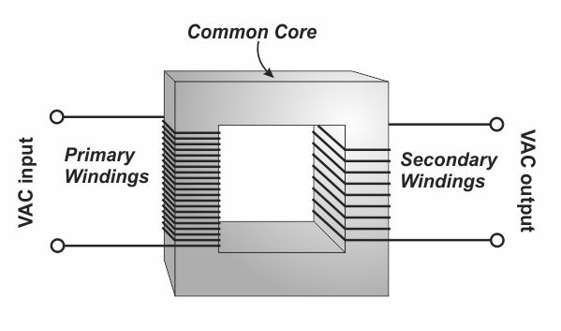
All transformers have a soft iron core, around which both the primary and secondary coils are wound.

(g) Explain the purpose of the core? (2 marks)
The soft iron core “channels” magnetic flux from the primary coils to the secondary coils. i.e. the core reduces “flux leakage” .✓✓

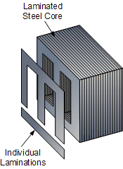
(h) Explain how constructing the core from thin laminations, as shown below, significantly reduces the energy losses in the transformer. (2 marks)
Laminations prevent large eddy currents being induced in the core due the rapidly changing magnetic flux. ✓ Smaller eddy currents are favourable as power lost is proportional to I². ✓

End of Section Two
SECTION THREE: Comprehension 20% (36 marks)
This section has two (2) questions. You must answer both questions. Write your answers in the spaces provided.
Spare pages are included at the end of this booklet. They can be used for planning your responses and/or as additional space if required to continue an answer.
- Planning: If you use the spare pages for planning, indicate this clearly at the top of the page.
- Continuing an answer: If you need to use the space to continue an answer, indicate in the original answer space where the answer is continued, i.e. give the page number. Fill in the number of the question that you are continuing to answer at the top of the page.
Suggested working time: 40 minutes.

Question 21 (18 marks)

Juno slingshots past Earth on its way to Jupiter

Article adapted from Science Daily’s Article: Juno slingshots past Earth on its way to Jupiter. October 8, 2013

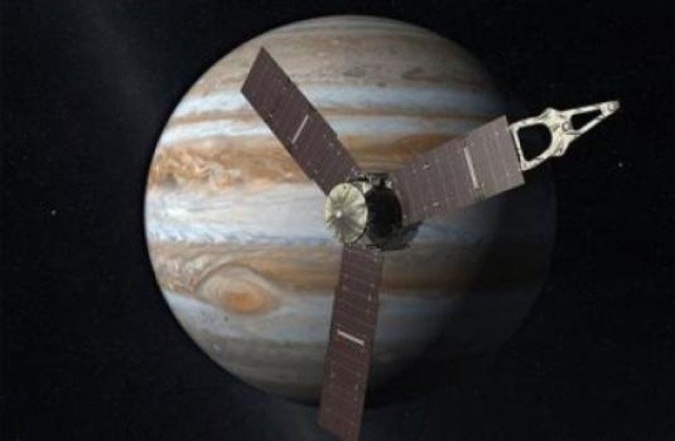
If you've ever whirled a ball attached to a string around your head and then let it go, you know the great speed that can be achieved through a slingshot maneuver.
Similarly, NASA's Juno spacecraft will be passing within some 563 km of Earth's surface at 3:21p.m. EDT Wednesday, Oct. 9, 2013 before it slingshots off into space on a historic exploration of Jupiter.
It's all part of a scientific investigation that began with an August 2011 launch. The mission will begin in earnest when Juno arrives at Jupiter in July 2016. Bill Kurth, University of Iowa research scientist and lead investigator for one of Juno's nine scientific instruments, the Waves instrument, says that the two years spent moving outward past the orbit of Mars before swinging past Earth makes the trip to Jupiter possible.
"Juno will be really smoking as it passes Earth at a speed of about 40 kilometres per second relative to the sun. But it will need every bit of this speed to get to Jupiter for its July 4, 2016 capture into polar orbit about Jupiter," says Kurth, who has been involved with the mission since the beginning. "The first half of its journey has been simply to set up this gravity assist with Earth”.
Kurth and colleagues UI Professor Don Gurnett and research scientist George Hospodarsky note that the real science will begin when Juno begins orbiting Jupiter some 33 times over the course of a year. Juno will be the first spacecraft to orbit Jupiter over its poles.
The UI-designed-and-built Waves instrument will examine a variety of phenomena within Jupiter's polar magnetosphere by measuring radio and plasma waves. It's one of nine experiments to be undertaken of the gas giant.
In particular, Juno will explore the solar system's most powerful auroras -- Jupiter's northern and southern lights -- by flying directly through the electrical current systems that generate them.
The Aurora is an incredible light show caused by collisions between electrically charged particles released from the sun that enter a planet’s atmosphere and collide with gaseous molecules. The lights are seen around the magnetic poles of the northern and southern hemispheres.
"Jupiter has the largest and most energetic magnetosphere, and to finally get an opportunity to study the nature of its auroras and the role radio and plasma waves play in their generation makes Juno a really exciting mission for me," says Kurth.
Juno's other major objectives include mapping the planet's magnetic and gravity fields to learn more about its deep interior including the size of its core.
Juno's destiny is a fiery entry into Jupiter's atmosphere at the end of its one-year science phase as a means of guaranteeing it doesn't impact Europa and possibly contaminate that icy world with microbes from Earth. This would jeopardise future missions to that moon designed to determine whether life had begun there on its own.

(a) Juno was launched in July 2011 to explore Jupiter. Explain why the probe’s trajectory brought it back to within 600 km of the Earth. (3 marks)
Juno was brought back towards to Earth to take advantage of the “slingshot effect” ✓ This is when the probe interacts with the Earth’s magnetic field ✓ this accelerates Juno as it takes some of the Earth’s momentum and kinetic energy ✓

(b) On October 9, 2013 Juno was 563 km above the Earth’s surface. At this instant it was within metres of another (Low-Earth orbit) satellite. Calculate the speed of this satellite. (5 marks)
mv²/r = GMm/r² ✓
v² = GM/r ✓
= (6.67 x 10⁻¹¹)(5.98 x 10²⁴)/(6.37 x 10⁶+ 563000) ✓✓
v = 7,590 m/s ✓

(c) The mass of Jupiter = 1.90 x 10²⁷ kg. Using this fact and other data from the text, find the average radius of Juno’s proposed orbit above Jupiter? (4 marks)
r³ = GMT²/4π²
= (6.67 x 10⁻¹¹)(1.9 x 10²⁷)(3.16 x 10⁷/33)²/4π² ✓✓
= 2.94 x 10²⁷ ✓
r = 1.43 x 10⁹ m ✓

(d) Explain why NASA have planned for Juno to orbit over Jupiter’s poles. (2 marks)
To investigate Jupiter’s magnetic field ✓ and study Jupiter’s auroras ✓
(e) Why do you think auroras are more prevalent at the magnetic poles? (2 marks)
At the poles, the magnetic flux lines are near vertical ✓ so charged particles experience less force and penetrate the atmosphere producing auroras. Charged particles entering at the equator would be completely deflected. ✓

(f) Why is NASA planning on crashing Juno into Jupiter at the end of its mission? (2 marks)
At the end of its mission, Juno will be crashed into Jupiter to prevent Juno ever crashing into Europa and contaminating it with microbes from Earth. ✓✓

Question 22 (18 marks)
Three-phase electric power
Article adapted from a Wikipedia article: https://en.wikipedia.org/wiki/Three-phase_electric_power
Three-phase electric power is a common method of alternating-current electric power generation, transmission, and distribution. It is a type of polyphase system and is the most common method used by electrical grids worldwide to transfer power. It is also used to power large motors and other heavy loads. A three-phase system is usually more economical than an equivalent single-phase at the same line to ground voltage because it uses less conductor material to transmit electrical power. The three-phase system was independently invented by Galileo Ferraris, Mikhail Dolivo-Dobrovolsky, Jonas Wenström and Nikola Tesla in the late 1880s.
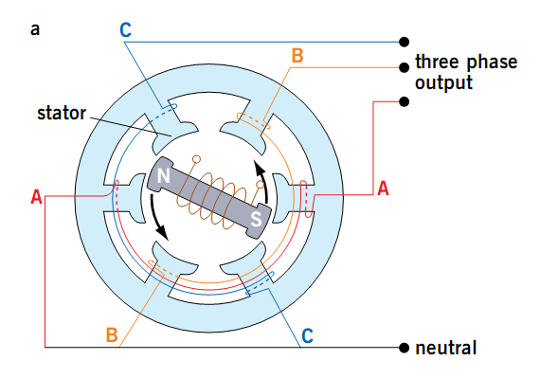
A simple three phase generator has a spinning magnet that rotates past three different sets of coils.
In a symmetric three-phase power supply system; three conductors each carry an alternating current of the same frequency and voltage amplitude relative to a common reference but with a phase difference of one third the period. The common reference is usually connected to ground and often to a current-carrying conductor called the neutral. Due to the phase difference, the voltage on any conductor reaches its peak at one third of a cycle after one of the other conductors and one third of a cycle before the remaining conductor. This phase delay gives constant power transfer to a balanced load.
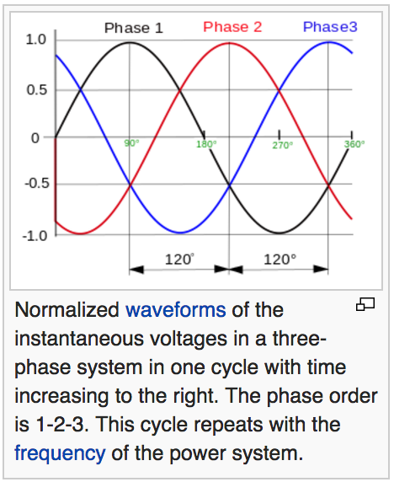
In a three‐phase system feeding a balanced load, the sum of the instantaneous currents of the three conductors is zero. In other words, the current in each conductor is equal in magnitude to, but with the opposite sign of, the sum of the currents in the other two. This is similar to the phenomenon of “total destructive interference” in wave motion.
Compared to a single-phase AC power supply that uses two conductors (phase and neutral), a three-phase supply with no neutral, the same phase-to-ground voltage and current capacity per phase can transmit three times as much power using just 1.5 times as many wires (i.e. three instead of two). Thus, the ratio of capacity to conductor material is doubled.

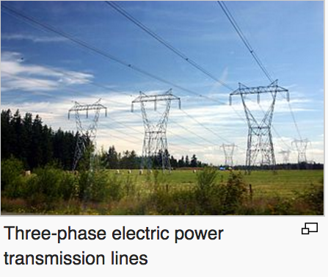
Three-phase systems may also utilise a fourth wire, particularly in low-voltage distribution. This is the neutral wire. The neutral allows three separate single-phase supplies to be provided at a constant voltage and is commonly used for supplying groups of domestic properties which are each single-phase loads. The connections are arranged so that, as far as possible in each group, equal power is drawn from each phase. Further up the distribution system, the currents are usually well balanced. Transformers may be wired in a way that they have a four‐wire secondary but a three wire primary while allowing unbalanced loads and the associated secondary‐side neutral currents.
The phase currents tend to cancel out one another, summing to zero in the case of a balanced load. This makes it possible to reduce the size of the neutral conductor because it carries little or no current. With a balanced load, all the phase conductors carry the same current and so can be the same size.
Most households are single-phase. In Australia, three-phase power might feed a multiple-unit apartment block, but the household loads are connected only as single phase. On a suburban street, every third house will be on the same phase. In lower-density areas, only a single phase might be used for distribution. Some large appliances may be powered by three-phase power, such as electric stoves and air conditioners. In these situations, the power company can connect a household to three-phase power.
Wiring for the three phases is typically identified by colour codes, which vary by country. Connection of the phases in the right order is required to ensure the intended direction of rotation of three-phase motors. For example, pumps and fans may not work in reverse. Maintaining the identity of phases is required if there is any possibility two sources can be connected at the same time; a direct interconnection between two different phases is a short-circuit.
(a) Explain why three phase power delivers three time more electrical energy than single phase. (2 marks)
Each of the three phases provides the same voltage and current as the others, just 120º apart in the cycle. So total power = 3 x I²R ✓✓

(b) In a three phase power distribution system, the three “neutral” wires are essentially joined and this common neutral wire carries very little current. Explain why this is the case.
(3 marks)
The three phases in the neutral wires sum to zero for every stage of their cycles. So there is theoretically no net current in the neutral wire. ✓✓✓

(c) Compared to single phase ac power (or dc), three time as much electrical energy can be transmitted for only 1.5 times the amount of conducting wire. Explain. (2 marks)
Single phase electricity requires 2 wires – active and neutral. Three phase only needs 3 separate active wires during transmission. So three times the power is transmitted with only 1.5 times the amount of power cable. ✓✓

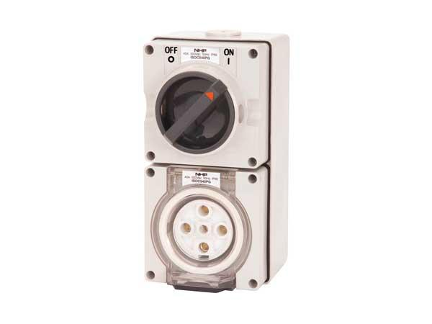
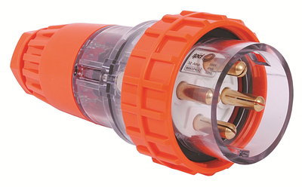
(d) In Australia a three-phase power socket takes a “five pin plug” as shown. Suggest the purpose of each of the five pins. (3 marks)
Three of the pins carry active for each of the 3 phases ✓
One pin is the shared neutral ✓
One pin is Earth ✓

(e) After a recent storm in Perth, Hamish noticed that his street had a “partial blackout”. That is every third house in the street had no power. Explain a possible cause of this observation.
(2 marks)
It is likely that the transmission cables for one of the phases was damaged. As the phases are usually balanced along a street, every third house would be on the same phase and therefore without power. ✓✓

(f) Briefly explain the operation of a simplified three-phase ac generator, clearly explaining how the three different phases are produced. Make reference to Faraday’s Law of electromagnetic induction in your answer. (4 marks)
- Electromagnets rotate past three sets of coils. ✓
- This causes a flux change in each of the coils sequentially ✓
- Therefore an alternating emf is induced in the coils (Faraday’s law) ✓
- Each induced emf is 120º out of phase, reflecting the angular separation of the coils in the three phase generator ✓

(g) If a person were to touch two of the three transmission cables at the same time, could they be electrocuted? Explain. (2 marks)
Yes ✓
They could still be electrocuted, as there is a potential difference between each cable at any point in time as they are out of phase. ✓

End of Questions

Additional Working Space

